

**Environments Dashboard**

**System Administration and Deployment Guide**

**Version 1.0**

**February 04, 2021**

# Revision

## Document revisions

|  |  |  |  |
| --- | --- | --- | --- |
| **Date** | **Author** | **Version** | **Change reference** |
| 02/04/2021 | Oleksandr Nikolaiev | 1.0 | Initial draft |
| 10/12/2021 | Oleksandr Nikolaiev | 1.1 | Updated deployment |
|  |  |  |  |
|  |  |  |  |
|  |  |  |  |
|  |  |  |  |
|  |  |  |  |
|  |  |  |  |

# Summary

This document describes a technical documentation about Azure Environments Dashboard web application

**Table of Contents**

Revision and Signoff sheet 2

Document revisions 2

Reviewers 2

Summary 3

1. Acronyms and abbreviations 5

2. Functional requirements 6

3. Integration design 6

3.1 Automatic processing 8

3.2 ASN batch processing 8

3.3 Manual processing. 8

3.4 Reprocessing 8

# Acronyms and abbreviations

The following acronyms and abbreviations are used throughout this document

|  |  |
| --- | --- |
| **Item** | **Definition** |
| VM | Virtual Maschine |
| AAD | Azure Active Directory |

# Summary

When your virtual machines are turned on, they consume 100% of the cost of the virtual machine and the resources attached to it. You can influence this by turning them off for a period when no one is working with them.

We have developed a special AzureDashboard for managing a fleet of virtual machines in a subscription. Each developer or project manager who has access to the AzureDashboard can independently at any time turn off or turn on the required VM.

# AppService deployment

## From GitHub

* Open GitHub link in a new browser -  <https://github.com/ciellosinc/CiellosAzureDashboard>
* Click on Deploy to Azure button.

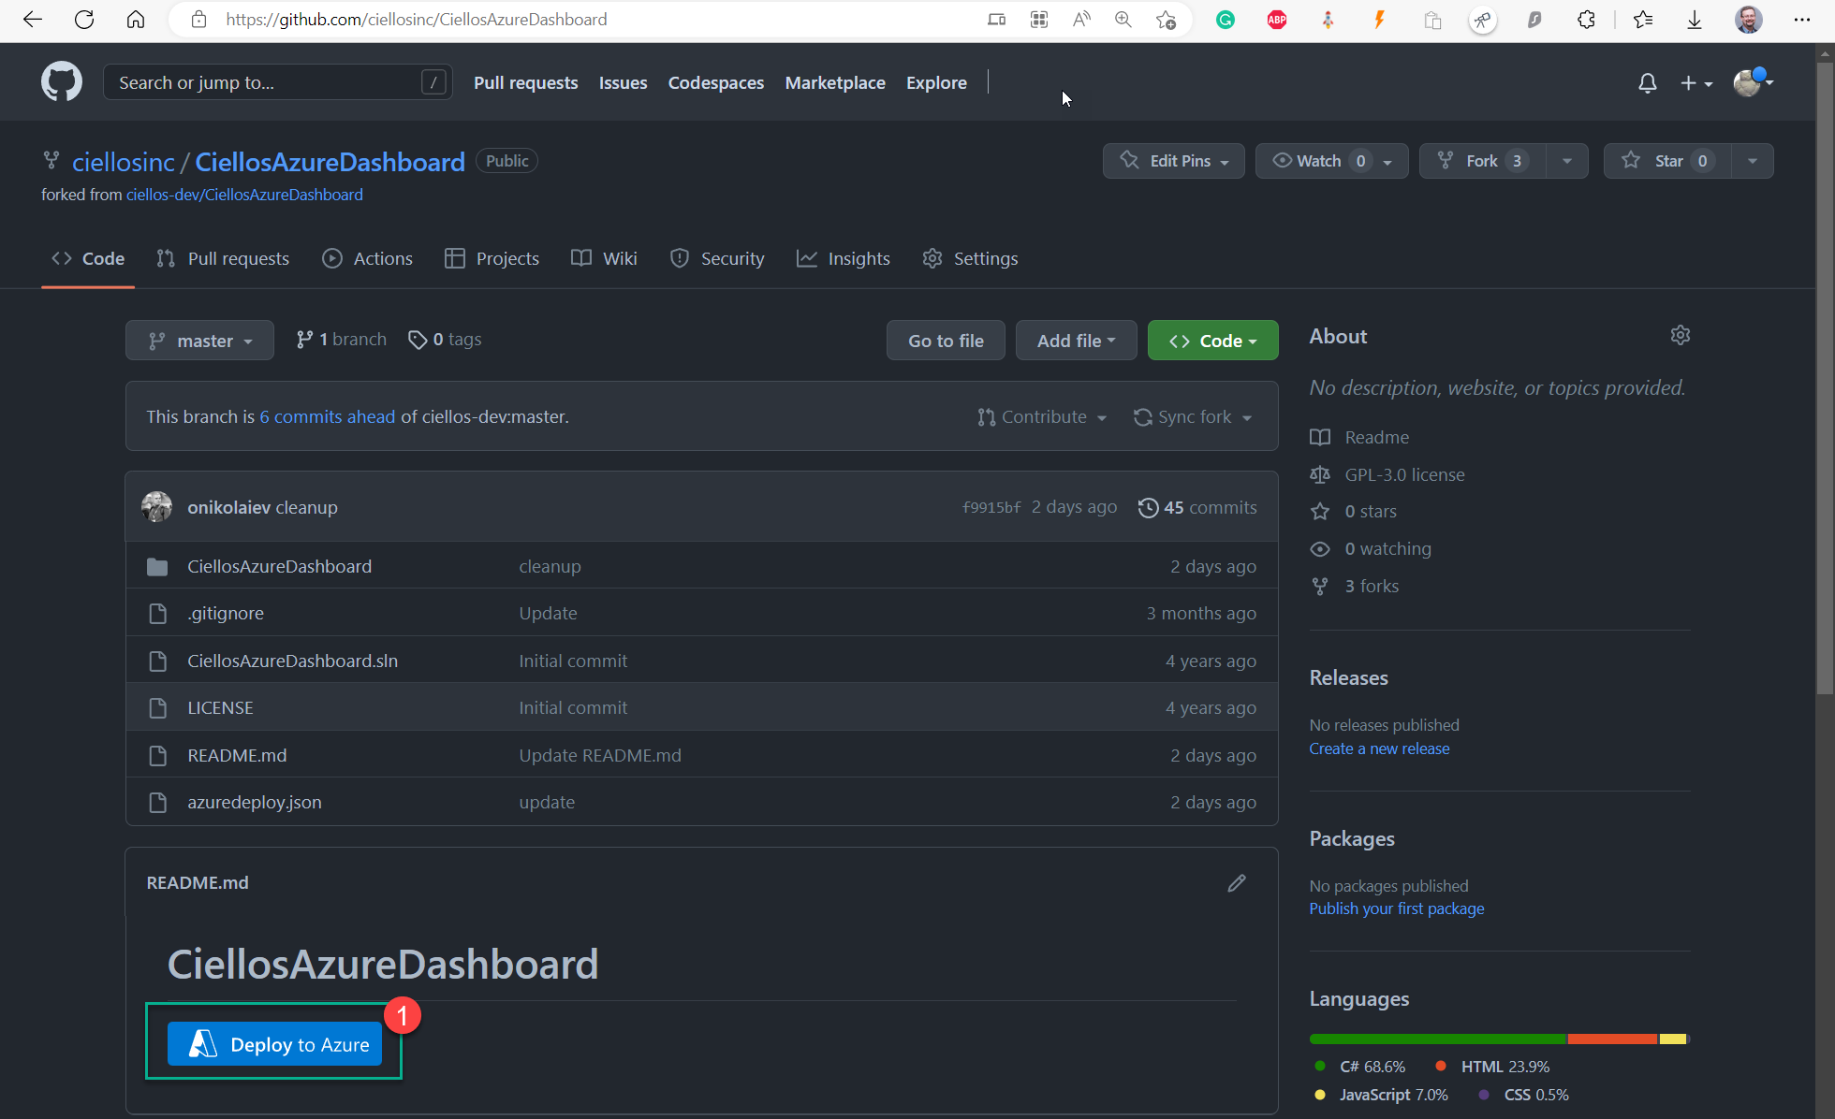

* Login to Azure with your Microsoft or O365 account. You must have at least a Contributor role on Azure subscription to deploy AppService.
* Select Subscription, Resource Group, Web App Name, Location, and RepoURL

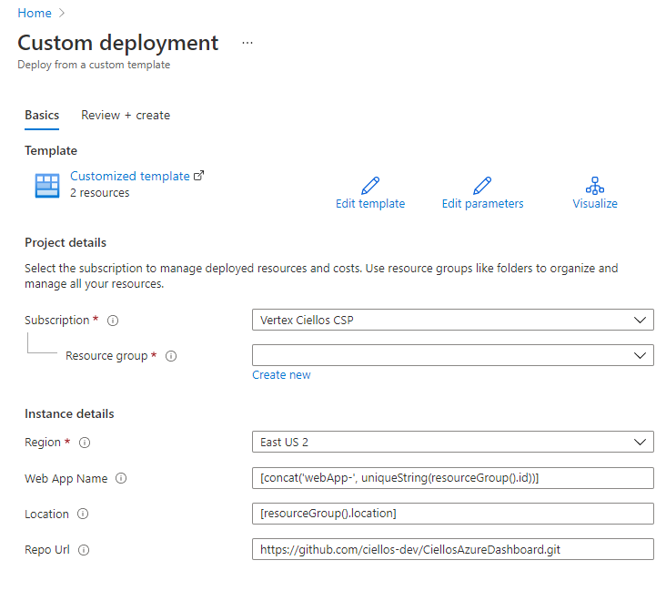

Please note that Web App Name will be used as your URL address.

* Click on Create button:

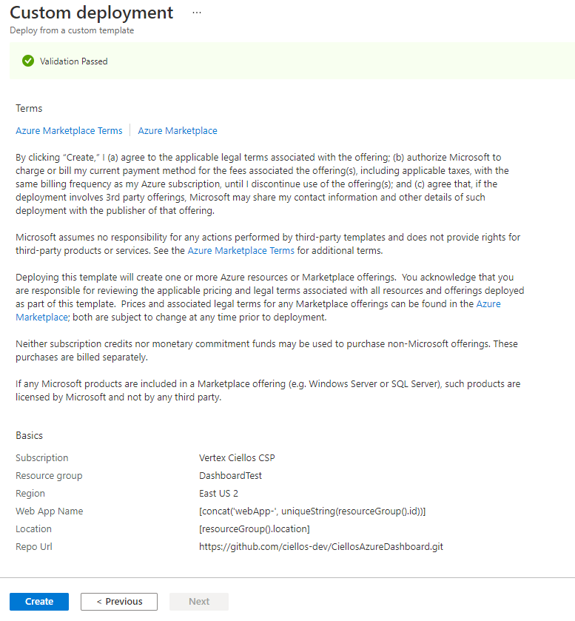

1. In a few minutes AppService will be deployed in the selected Azure Subscription:

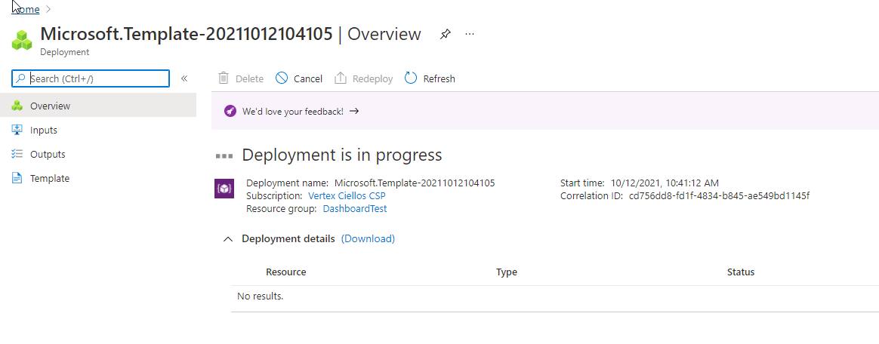

## From VisualStudio

Deployment from VisualStudio

# AppService configuration

* Click on Browse to link and you will be redirected to Deployed Site. You will get the following error:

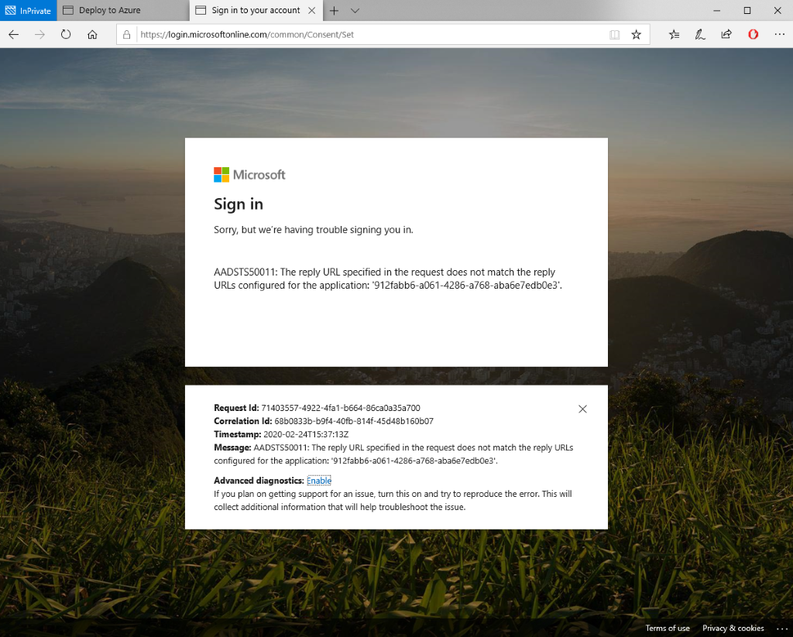

* User should have assigned ‘Cloud application administrator’ or ‘Application administrator’ Azure Active Directory roles.
* Go to Azure portal / Azure Active Directory /  App registrations and create new Application
* Enter the Name of Application and Redirect URI <your deployed site URL>/signin-oidc

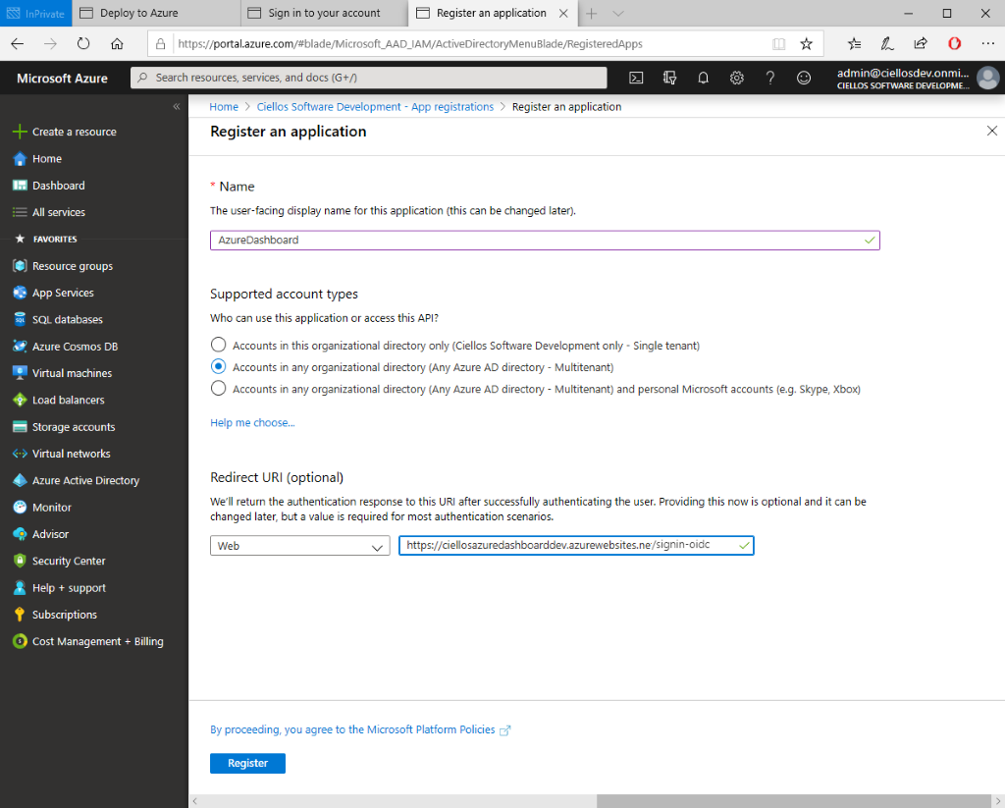

* Click on Register button and after Application is created Open it
* Please note Application (client) ID and Directory (tenant) ID

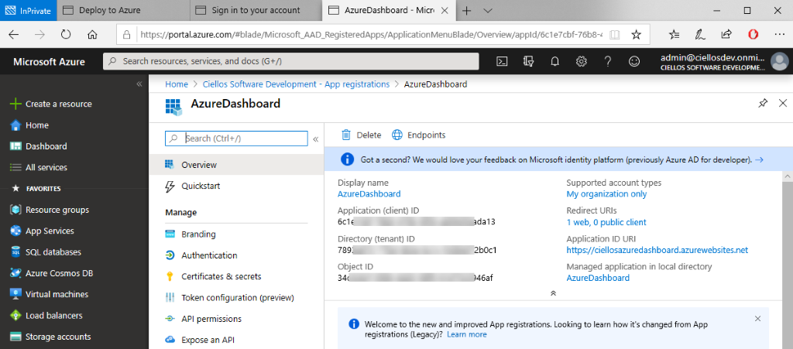

* Click ‘Authentication’ and Select ‘ID tokens’ in ‘Implicit grant’ section and press ‘Save’   
  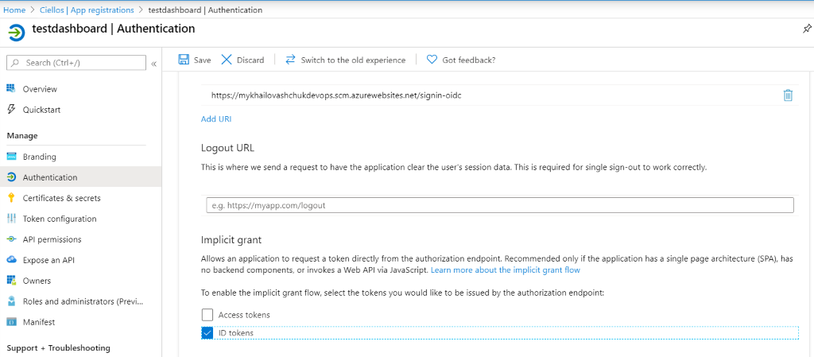
* Open “Expose an API”
* Click on Application ID URI if it is empty you will be proposed to create random, accept it. Leave it as is.
* Click on +Add Scope button

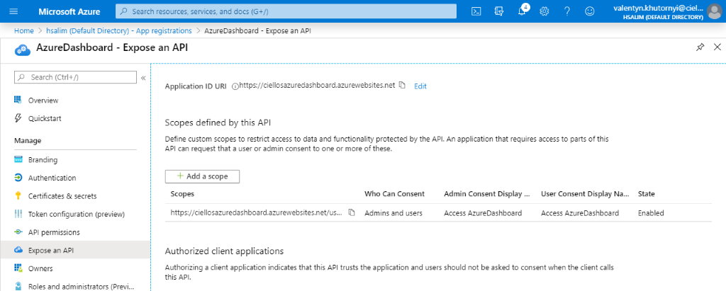

* Add scope name user_impersonation and fill other fields like on the picture below

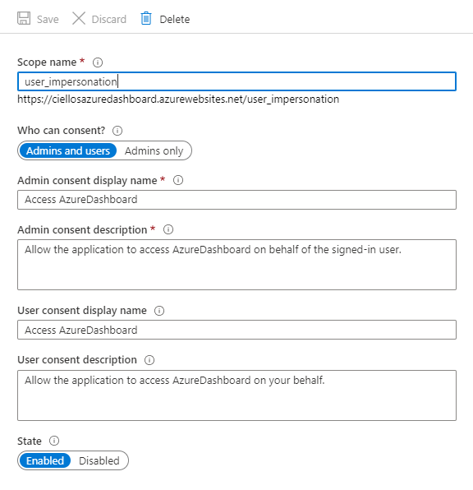

* Go to AppServices blade and select deployed site then scroll down and select App Service Editor (Preview)

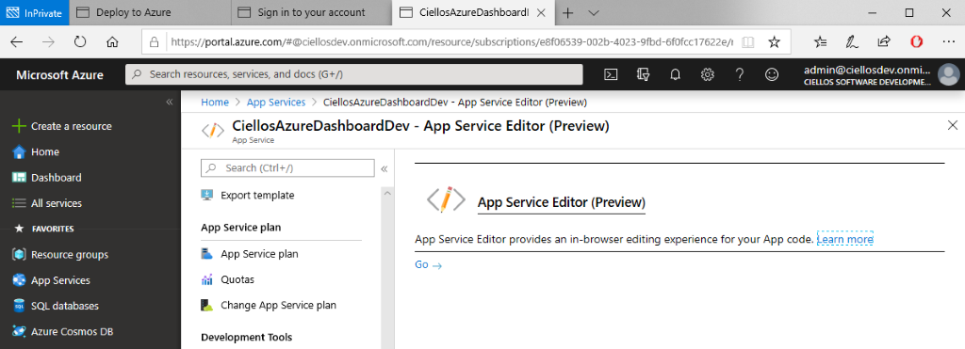

* Click on the “Go ->” link in new windows opens AppService editor. Select appsettins.json file for editing

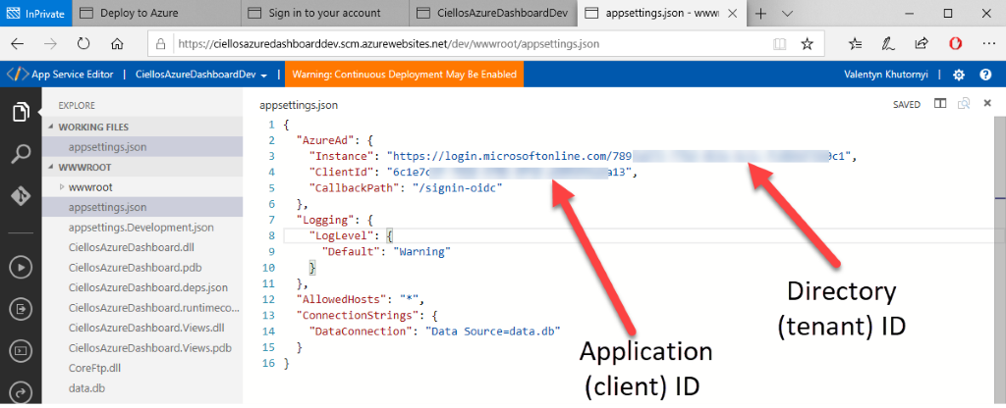

* Click ‘API Permissions’ then press the ‘Grant admin consent for Ciellos’   
  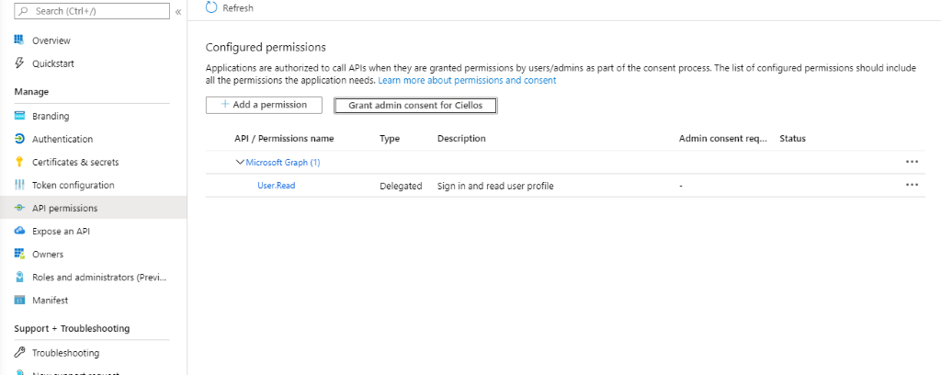
* Fill noted on 11 step  Directory (tenant) ID and Application (client) ID values

# Environment Dashboard

Now restart the AppService and try to open its URL in a browser.

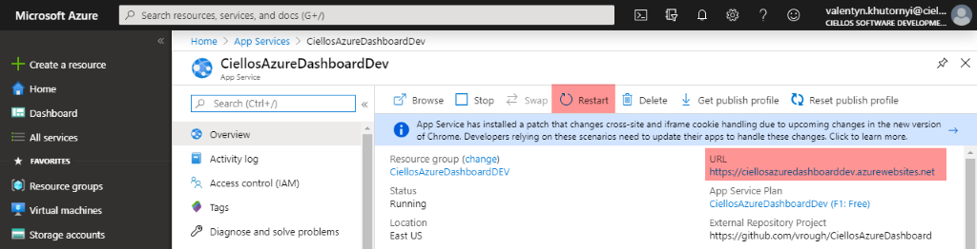

* Start page of the Dashboard should look like on the picture

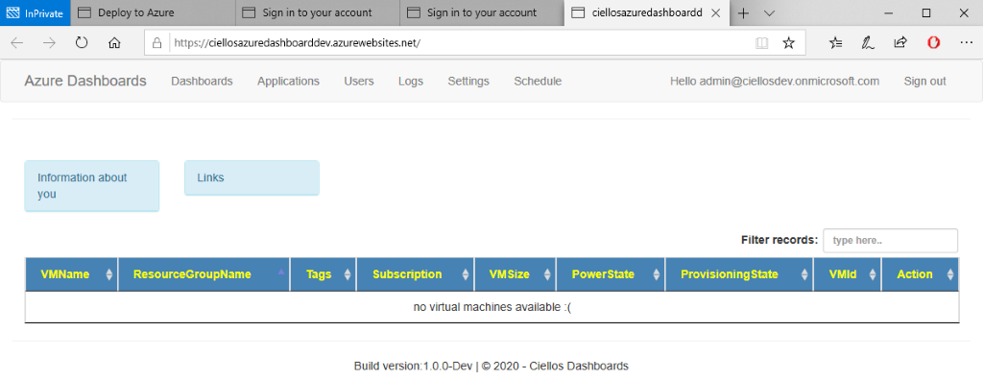

* Go to the Settings menu and download the public certificate

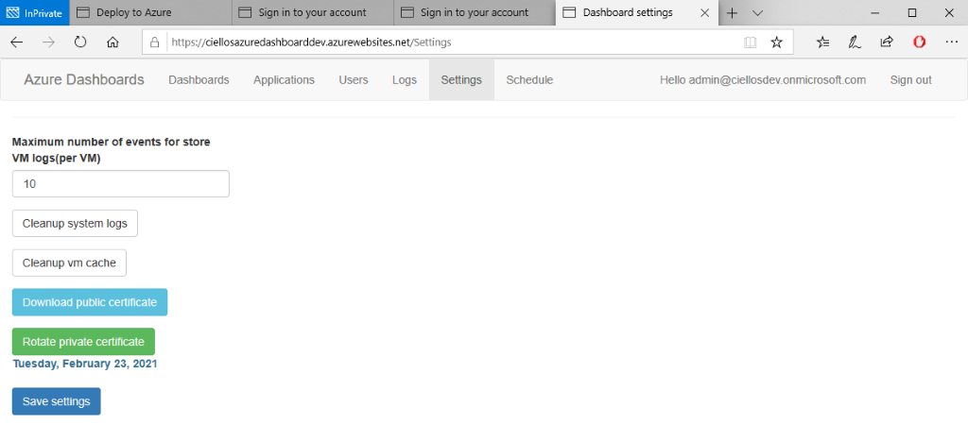

* Go to users' menu and delete [test.test@test.com](mailto:test.test@test.com) user. The second row should be displayed user account under which you log in to the dashboard.

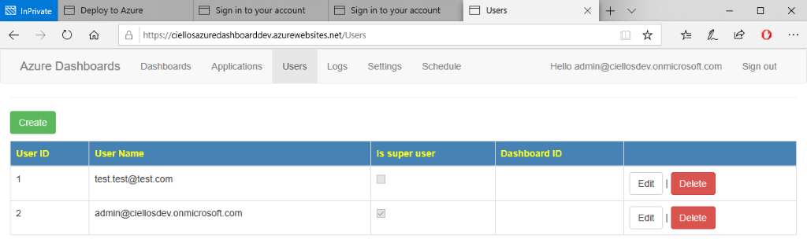Make sure you have

* Go to the Application menu and fill the field with values noted on step 11. Leave Client secret filed blank

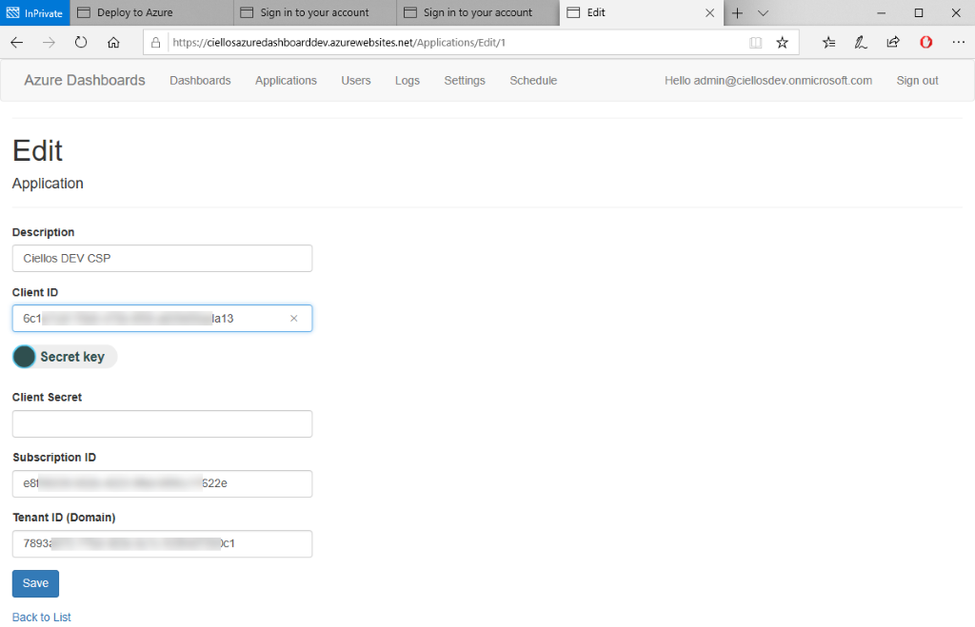

* Go to Dashboards menu and move Application from Available to Selected

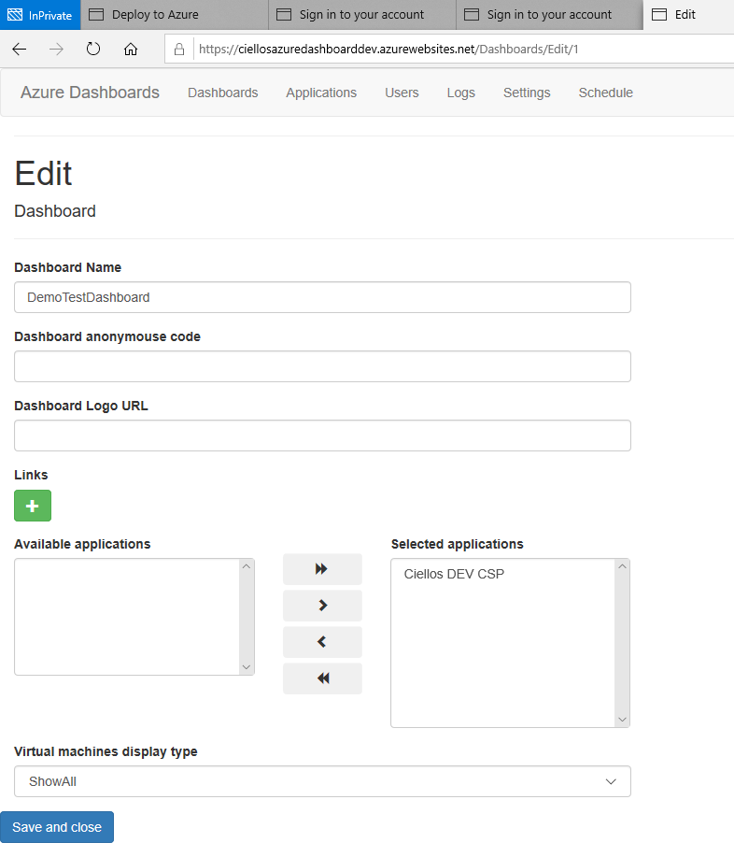

* Return to AppService settings on the Azure portal. Go to Certificate & secrets and upload certificate downloaded on step 20

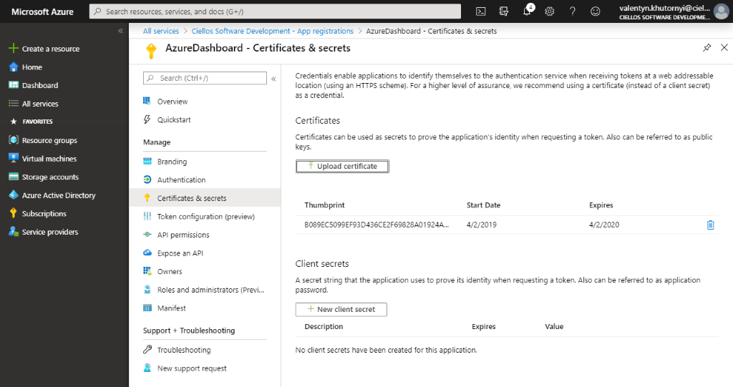

* Go to Subscription settings select Access control (IAM) and assign “DevTest Labs Users” to “AzureDashboard” application

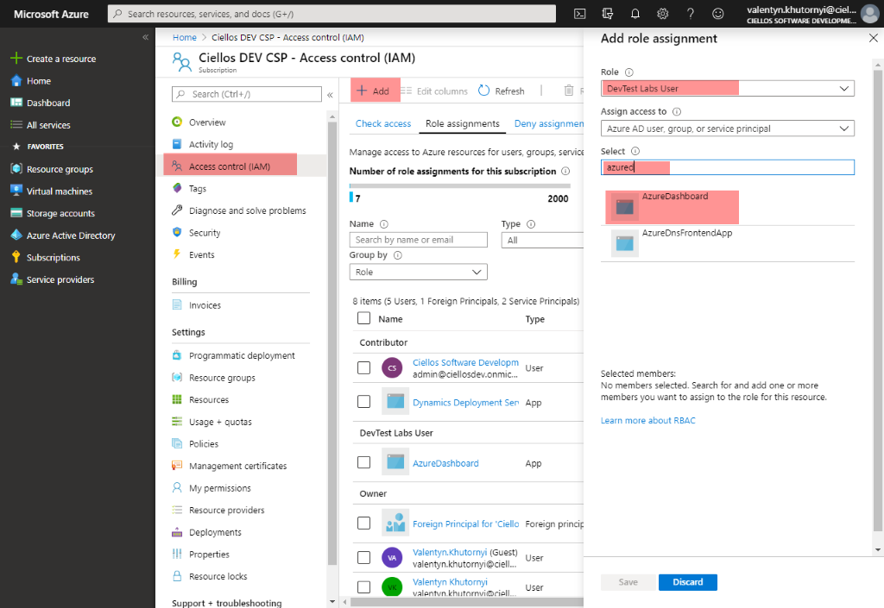

* Now on AzureDashbord site, all VMs deployed under selected subscription should be displayed

